
Module Code | : | CT026-3-2-HCI – Human Computer Interaction
Intake Code | : | APD2F2509CS(CYB)
Lecturer Name | : | Ms. AIDA ZAMNAH BINTI ZAINAL ABIDIN
Hand in Date | : | 2nd March 2026
Hand out Date | : | 8th Jun 2026
Group No. | : | Group T03G4
Group Leader | : | MOHAMMED YOUSEF MOHAMMED MOHAMMED
Project Title | : | MySST

TABLE OF CONTENTS
Table of Contents
1.0 INTRODUCTION 1
1.1 MySST 1
1.2 MySST Website 1
2.0 PROJECT OBJECTIVES 2
3.0 PROBLEM STATEMENTS 3
3.1 Problem 1: Unprofessional and Outdated Visual Elements 3
3.2 Problem 2: Poor Empty State Design 6
3.3 Problem 3: Unclear and Confusing UI Elements 8
4.0 PROPOSED SOLUTION 11
4.1 Solution 1: Redesigning the Interface with Modern and Professional Visual Elements 11
4.2 Solution 2: Redesigning Empty States for Clearer and More Engaging User Guidance 12
4.3 Solution 3: Redesigning UI Elements for Clarity and Improved Usability 13
5.0 WORKLOAD DISTRIBUTION 14
6.0 PROJECT TIMELINE (GANTT CHART) 16
7.0 Progress Report and Meeting Minutes ……………………………………………………17
9.0 Video Presentation Link …………………………………………………………………... 24

- INTRODUCTION

1.1 MySST

Figure 1 MySST Logo

The MySST (Malaysia Sales and service tax) portal is an official online portal of the Royal Malaysian Customs department which offers businesses to manage their SST registration, tax returns, pay matters as well as receive compliance notices.

1.2 MySST Website
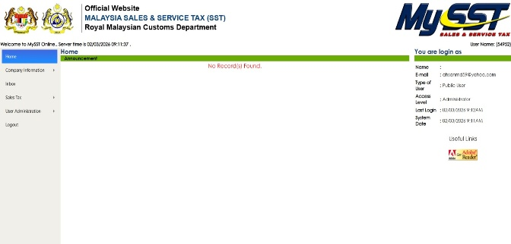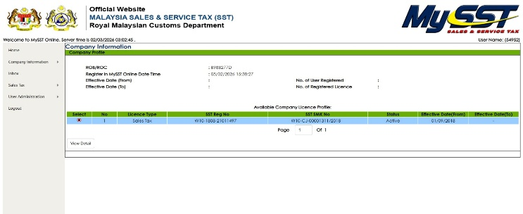
Nowadays, registered businesses in Malaysia rely on the MySST portal to fulfil their Sales and Service Tax obligations online. Through the portal, users can view their licence details, submit tax returns, track payment history, and receive official reminders from the Royal Malaysian Customs Department.
- PROJECT OBJECTIVES
1. Streamline Navigation and User Interface
The primary objective is to simplify the portal's navigation by reducing redundant sidebar tabs and sub-menus to lower the user's cognitive load. By decluttering the login panel and breaking down dense blocks of text into organized sections, the interface will prioritize essential information. This ensures a faster, more intuitive user journey where only relevant data is presented at each step.
2. Standardize Visual Design and System Feedback
This goal focuses on creating a consistent design language across all pages to eliminate stylistic clashing and "error-like" red messaging. A uniform color scheme and improved table layouts will be implemented to ensure that data remains readable without horizontal cramping or overflow. Replacing harsh notifications with friendly, straightforward messages will create a more cohesive and professional user experience throughout the portal.
3. Improve Dashboard Utility and Data Accessibility
The final objective is to transform the empty homepage into a functional dashboard that automatically displays deadlines, submission statuses, and tax summaries upon login. Additionally, the usability of the inbox will be enhanced by adding search functionality and replacing cryptic file names with understandable titles. These changes shift the portal from a static repository into a proactive tool that provides immediate value to the user.

3.0 PROBLEM STATEMENTS

3.1 Problem 1: Unprofessional and Outdated Visual Elements
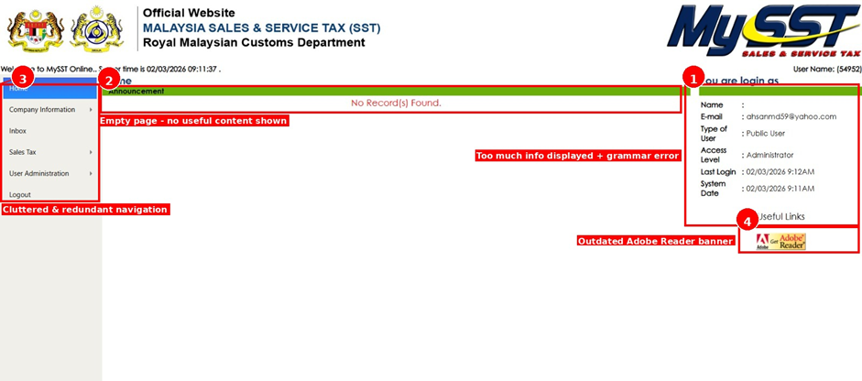
Figure 3.1.1 shows the MySST Homepage which serves as the main landing page that users see after logging in.
POINT | OBSERVATION | UX CATEGORY
1 | Too much info + grammatical errors | Clutter & Quality Control: Displays "You are login as" (grammar) and excessive metadata that could be hidden in a profile dropdown to save space.
2 | Empty page - no useful content | Information Architecture: The "prime real estate" of the screen is wasted on a "No Record(s) Found" message rather than a dashboard or quick actions.
3 | Cluttered & redundant navigation | Navigation Design: The sidebar uses outdated styling and appears to repeat options that could be streamlined for better flow.
4 | Outdated Adobe Reader banner | Visual Hierarchy & Trust: Using legacy web assets (like the 2000s-era Adobe button) makes the site feel unmaintained and less secure.

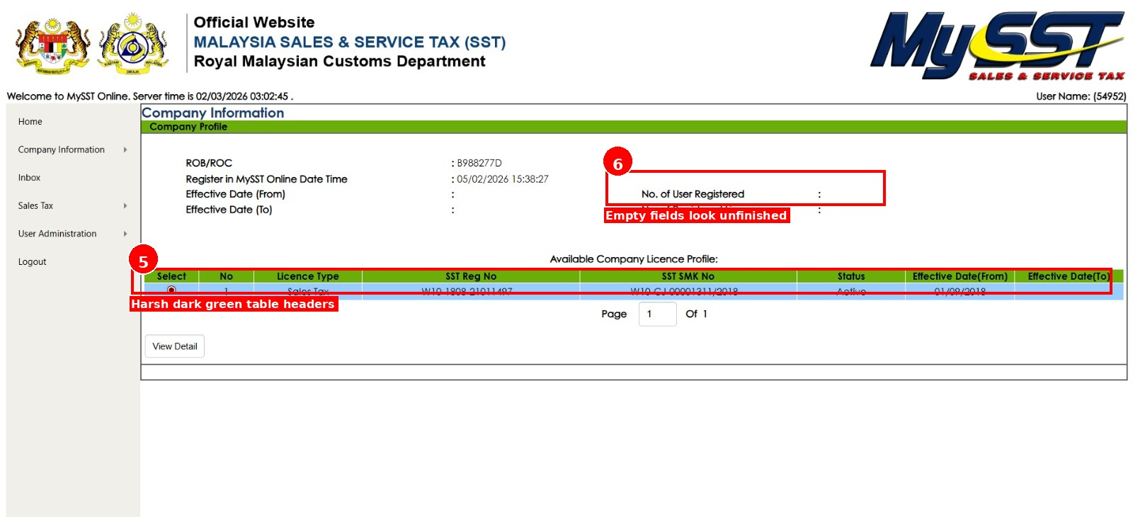
Figure 3.1.2 shows the Company Profile page that displays the registered company’s business details.
POINT | OBSERVATION | UX CATEGORY
5 | Harsh dark green table headers | Visual Design & Accessibility: The high-saturation green headers create unnecessary visual noise and may lead to poor text-to-background contrast, making the data harder to scan.
6 | Empty fields look unfinished | Data Integrity & Feedback: Displaying labels like "No. of User Registered" with blank values creates uncertainty. It is unclear if the data is missing, still loading, or simply zero.

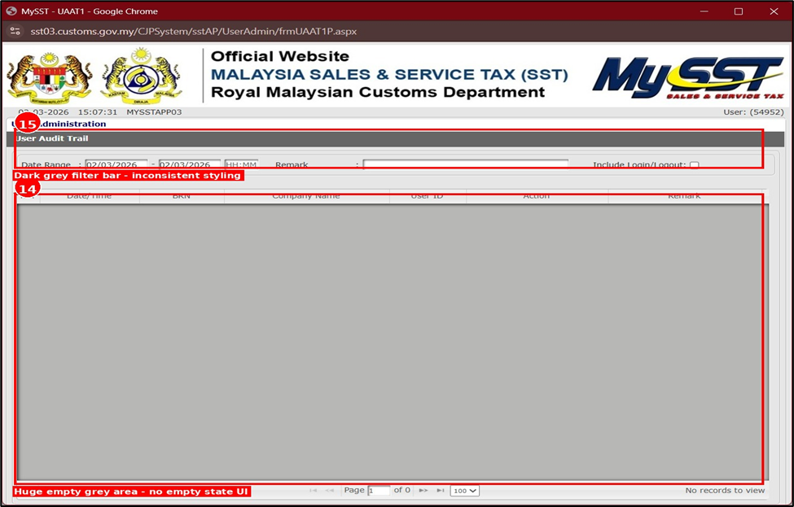
Figure 3.1.3 shows the User Audit Trail page that allows administrators to track and monitor all user activity.
POINT | OBSERVATION | UX CATEGORY
15 | Dark grey filter bar - inconsistent styling | Consistency & Standards: The dark grey headers on this page conflict with the green styling found on other pages, breaking the visual language of the portal.

3.2 Problem 2: Poor Empty State Design
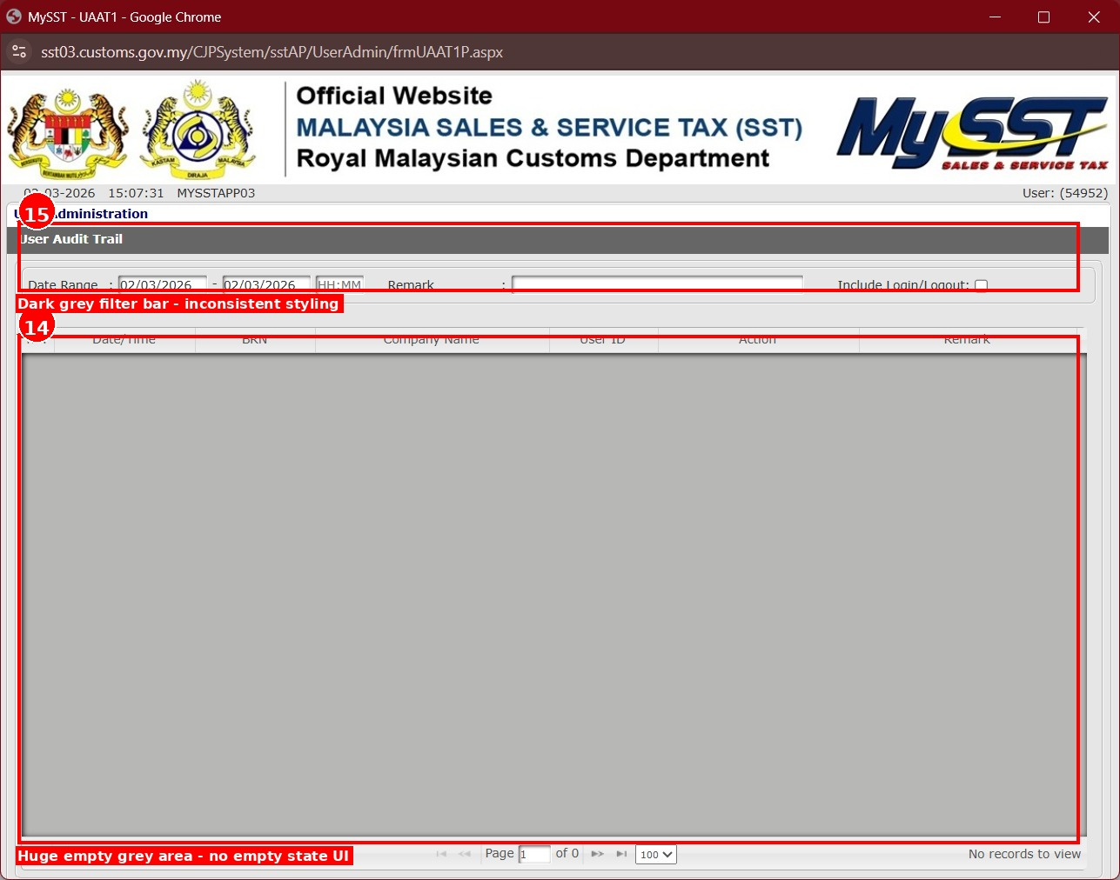
Figure 3.2.1 shows the User Audit Trail page that allows administrators to track and monitor all user activity.
POINT | OBSERVATION | UX CATEGORY
14 | Huge empty grey area - no empty state UI | System Status & Feedback: A massive blank grey space lacks instructional "Empty State" design, leaving the user without guidance on how to populate the list.

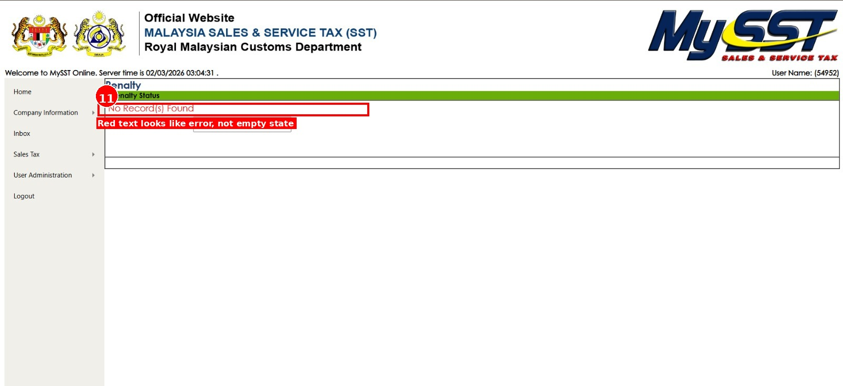
Figure 3.2.2 shows the Penalty Status page that allows registered businesses to check whether any penalties have been issued.
POINT | OBSERVATION | UX CATEGORY
11 | Red text looks like error, not empty state | System Status & Feedback: Using red text for "No Record(s) Found" triggers an "error" alarm in users' minds, even when the state is normal.

3.3 Problem 3: Unclear and Confusing UI Elements
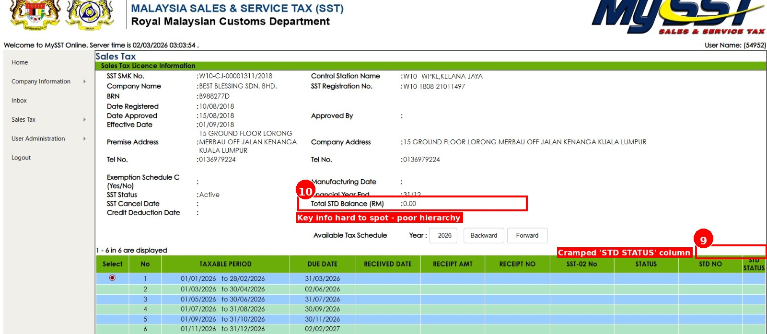
Figure 3.3.1 shows the Sales Tax page that provides a full overview of a company’s SST license details.
POINT | OBSERVATION | UX CATEGORY
9 | Cramped "STD STATUS" column | Table Layout: Insufficient padding and width in table columns make important status indicators difficult to read.
10 | Key info (Total Balance) hard to spot | Visual Hierarchy: Critical financial data is buried in a dense layout without proper emphasis or font-weight differentiation.

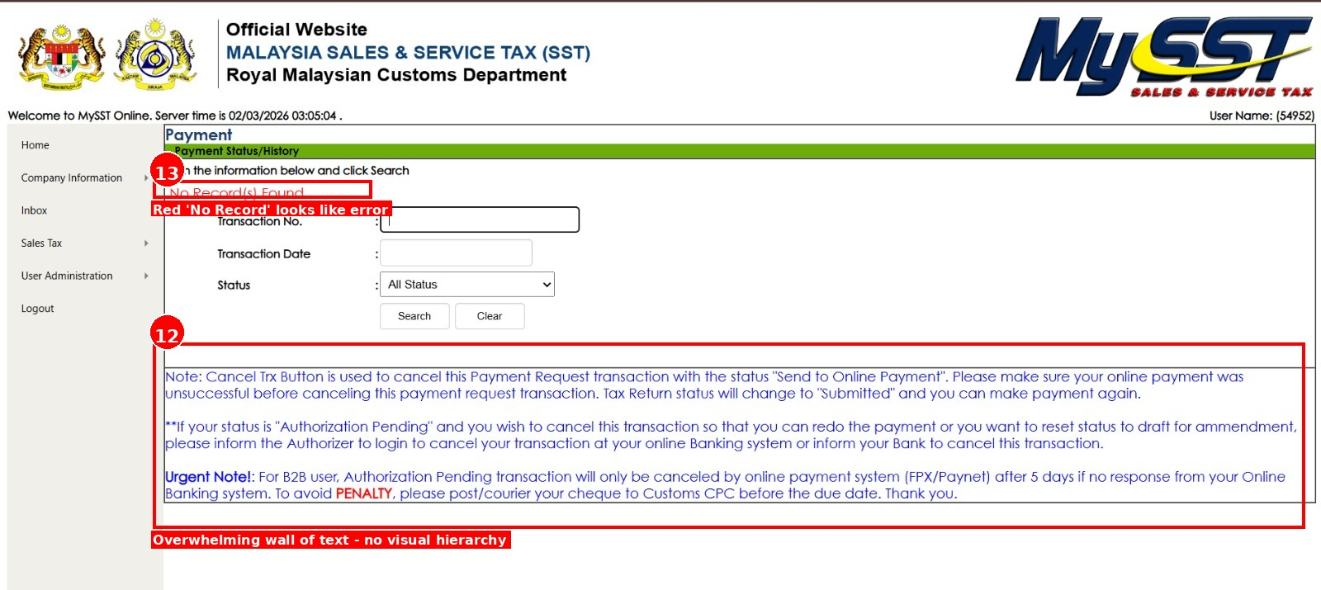
Figure 3.3.2 shows the Payment Status page that enables users to search and review the history of their SST tax payments.
POINT | OBSERVATION | UX CATEGORY
12 | Overwhelming wall of text | Content Strategy: Important instructions are presented as a dense block of text without bullets or bold formatting, making them difficult to scan or skip.
13 | Red text looks like an error | Semantic Accuracy: Using red for "No Record(s) Found" unnecessarily alarms users by mimicking a critical system failure.

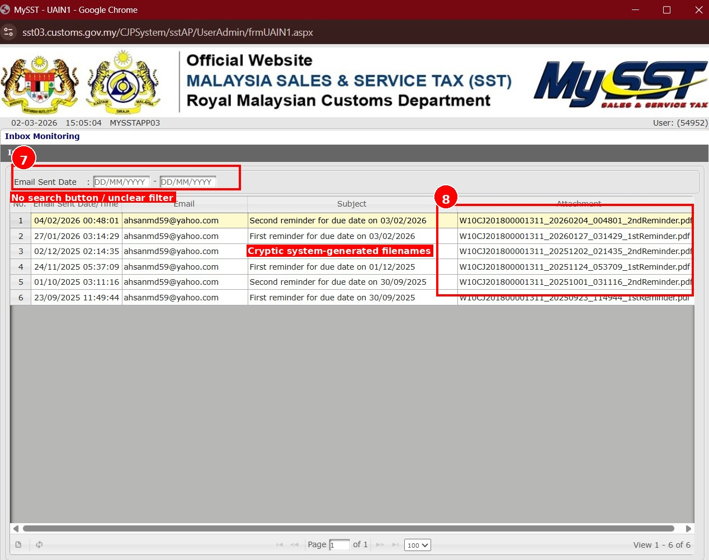
Figure 3.3.3 shows the Inbox page that acts as a notification center where the system sends official reminder emails.
POINT | OBSERVATION | UX CATEGORY
7 | No search button / Unclear filter | Usability & Flow: Filters lack an explicit "Submit" or "Search" action, leaving users unsure how to trigger data updates.
8 | Cryptic system-generated filenames | User-Centricity: Long, alphanumeric filenames (e.g., W10CJ2018...) are difficult to distinguish without opening the file.

4.0 PROPOSED SOLUTION

4.1 Solution 1: Redesigning the Interface with Modern and Professional Visual Elements
FIGURE | POINT | UX PROBLEM AREA | PROPOSED UI/UX SOLUTION
3.1.1 | 1 | Clutter & Quality Control | Profile Dropdown & Copy Edit: Replace the static sidebar text with a "User Profile" icon in the top header. Moving metadata (Last Login, System Date) into a hover or click-based dropdown reduces clutter. Correct text to: "Logged in as: [Name]".
3.1.2 | 2 | Information Architecture | Dynamic Dashboard View: Replace the "No Record(s) Found" message with a modular dashboard. This area should feature interactive widgets such as "Recent Filings," "Upcoming Deadlines," or "Quick Action" buttons (e.g., File New Return).
3.1.3 | 3 | Navigation Design | Collapsible Sidebar: Modernize the navigation using a "hamburger" or collapsible menu icon. Implement a cleaner, flat-design aesthetic with clearer grouping of related functions (e.g., grouping "User Administration" under a "Settings" category).
3.1.4 | 4 | Visual Hierarchy & Trust | Remove Legacy Assets: Permanently remove the "Get Adobe Reader" banner. Replace it with a "Help & Resources" section in the footer containing modern web-standard links or internal FAQ documentation to restore professional trust.

4.2 Solution 2: Redesigning Empty States for Clearer and More Engaging User Guidance
FIGURE | POINT | UX PROBLEM AREA | PROPOSED UI/UX SOLUTION
3.2.1 | 5 | Visual Design and Accessibility | Subdued Color Palette: Replace the high-saturation green headers with neutral, soft-toned colors (such as light grey or navy blue) and high-contrast text. This improves readability and reduces visual strain for the user.
3.2.2 | 6 | Data Integrity and Feedback | Handling Empty States: Instead of leaving fields blank, use clear indicators such as "0," "N/A," or "None" to confirm the system has successfully loaded the data. Alternatively, hide empty fields until they contain relevant information.

4.3 Solution 3: Redesigning UI Elements for Clarity and Improved Usability
FIGURE | POINT | UX PROBLEM AREA | PROPOSED UI/UX SOLUTION
3.3.1 | 9 | Visual Uniformity | Style Guide: Apply a unified, neutral color palette (soft blues/greys). Increase table padding to ensure text does not touch borders.
3.3.1 | 10 | Hierarchy | Financial Summary Cards: Place "Total Balance" in a high-visibility card at the top of the page with bolded fonts.
3.3.2 | 12 | Readability | Information Chunking: Convert dense instructions into bulleted lists or collapsible "How-to" accordions.
3.3.2 | 13 | Visual Language | Neutral Messaging: Use soft grey for "No record" messages to distinguish informative states from system errors.
3.3.3 | 7 | Interaction Design | Explicit Action Buttons: Add a clear, primary-colored "Search" or "Apply Filter" button next to date ranges.
3.3.3 | 8 | Content Design | Human-Readable Names: Rename files to include the document type and period, for example: “2nd_Reminder_Feb_2026.pdf”.

5.0 WORKLOAD DISTRIBUTION

Projext Stage | Task Description | Responsible Member | Sign
Proposal Development | Introduction | Mahrus | MAHRUS
 | Problem Statement | Abdullah | ABDO
 | Proposed Solution | Ahmed | AHM
 | Workload Distribution & Gantt Chart | Mohammed Yousef | MO
Stage 1: User, Tasks & Environment Analysis | Stakeholder Identification & Justification | Mohammed Yousef | MO
 | Selection of Data Gathering Methods & Justification | Mohammed Yousef | MO
 | Data Gathering Execution | Mohammed Yousef | MO
 | User Profile Table & Requirements | Mohammed Yousef | MO
 | Hierarchical Task Analysis (HTA) for 2 Goals | Mohammed Yousef | MO
Stage 2: Usability Goals & Competitive Analysis | Selection of 3 Usability Goals & Justification | Abdullah | ABDO
 | Mapping Usability Goals with Design Guidelines | Abdullah | ABDO
 | Competitive Analysis (3 Competitors vs Current Website) | Abdullah | ABDO
 | Impact of Competitive Analysis on Proposed Design | Abdullah | ABDO
Stage 3: Design & Prototype | Parallel Design Sketches (4 pages per member) | Ahmed | AHM
 | Peer-to-Peer Evaluation | Ahmed | AHM
 | Participatory Design (Card Sorting) | Ahmed | AHM
 | Style Guide Development | Ahmed | AHM
 | Prototype Development using Figma / Adobe XD | Ahmed | AHM
Stage 4: Formative Evaluation | DECIDE Framework | Mahrus | MAHRUS
 | Usability Testing Instructions Template | Mahrus | MAHRUS
 | Usability Testing Execution & Report | Mahrus | MAHRUS
 | Heuristic Evaluation & Impact Analysis | Mahrus | MAHRUS
Documentation & Reporting | Progress Reports and Meeting Minutes | Abdullah | ABDO
 | Final Documentation Compilation | Mohammed Yousef | MO

6.0 PROJECT TIMELINE (GANTT CHART)
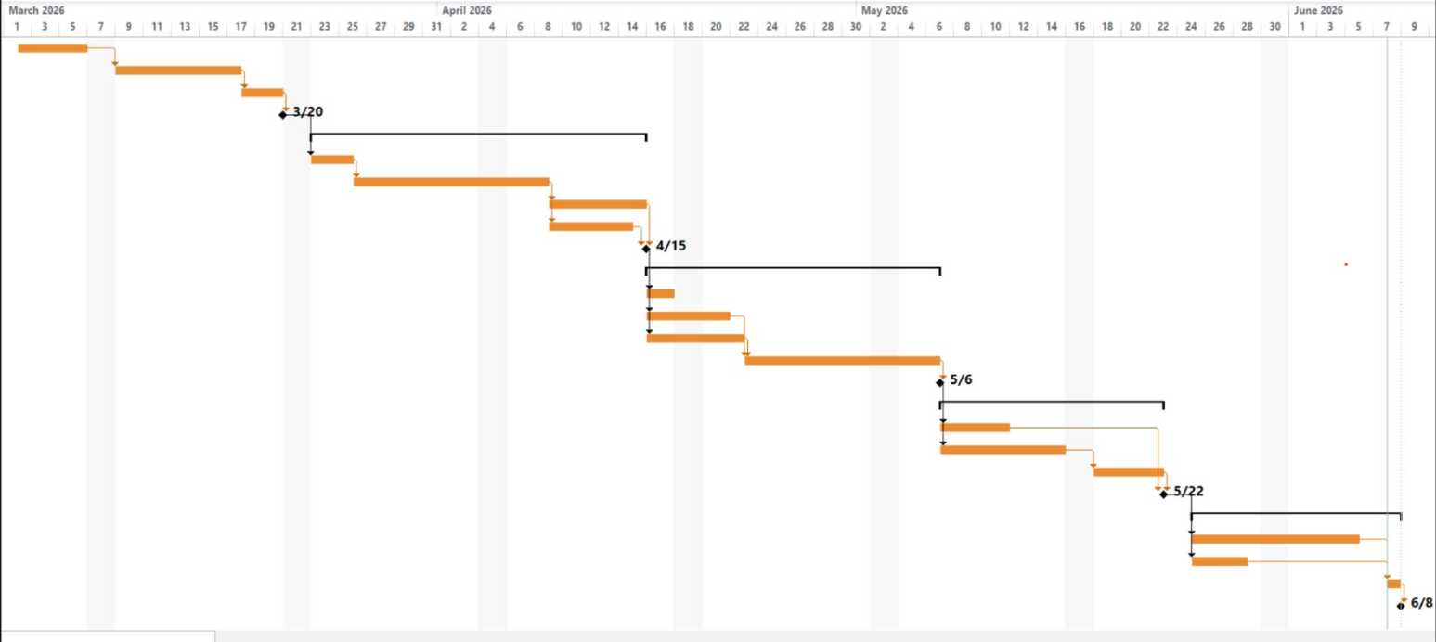
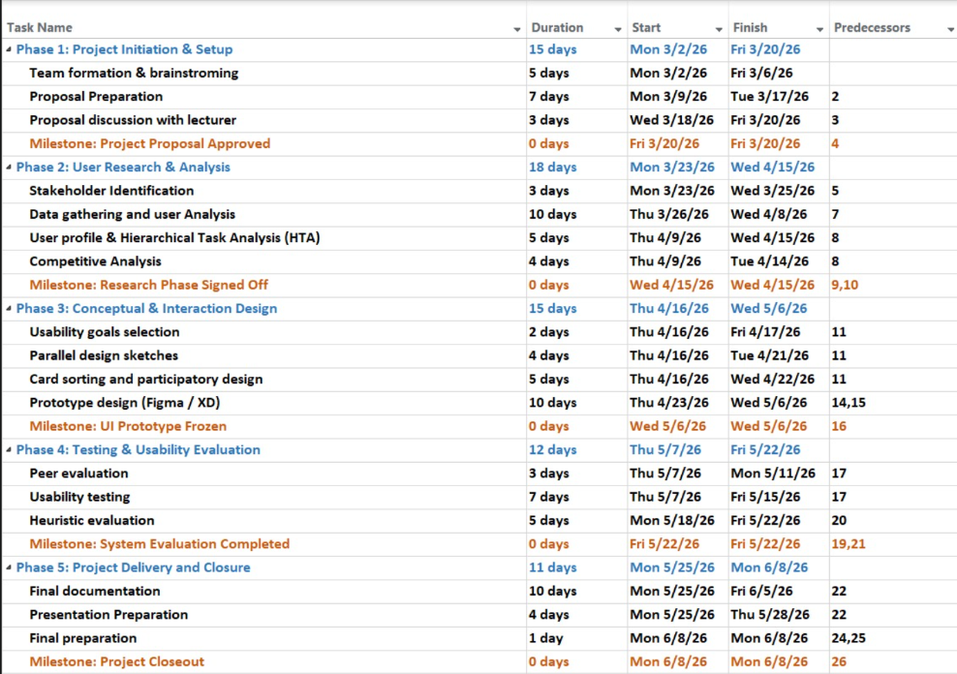Figure 8 shows the Project Gantt Chart outlining the 14-week timeline and task status

7.0 Progress Report and Meeting Minutes

Meeting | Date | Duration | Organizer
Meeting 1: Project Selection and Proposal Planning | 3 March 2026 | 15 minutes | Mohammed Yousef
Meeting 2: User Research and Survey Planning | 16 March 2026 | 18 minutes | Mohammed Yousef
Meeting 3: User Profile, HTA and Task Analysis Review | 31 March 2026 | 22 minutes | Mohammed Yousef
Meeting 4: Usability Goals and Competitive Analysis | 14 April 2026 | 17 minutes | Abdulah
Meeting 5: Stage 3 Prototype, Card Sorting and Design Rationale | 5 May 2026 | 26 minutes | Ahmed
Meeting 6: Stage 4 Evaluation and Final Report Review | 8 June 2026 | 24 minutes | Mahrus

Meeting 1: Project Selection and Proposal Planning
Microsoft Teams Meeting
Date: | 3 March 2026
Start Time: | 8:00 PM
End Time: | 8:15 PM
Duration: | 15 minutes
Organizer: | Mohammed Yousef
Attendees: | Mohammed Yousef, Ahmed, Abdullah, Mahrus
Location: | Microsoft Teams Online Meeting
Agenda
1. Discuss possible websites for the HCI redesign project.
2. Select the final website for the assignment.
3. Divide proposal tasks among team members.
Discussion Summary
The team discussed several possible websites for the HCI redesign assignment. After comparing different options, the team agreed to redesign the official MySST / Malaysia Sales and Service Tax portal under the Royal Malaysian Customs Department. The team selected this portal because it showed several usability issues, such as outdated visual design, confusing navigation, and unclear information presentation.
The proposal workload was divided among the team members. Mahrus was assigned the Introduction, Abdullah was assigned the Problem Statement, Ahmed was assigned the Proposed Solution, and Mohammed Yousef was assigned the Workload Distribution and Gantt Chart.
Decisions Made
- The selected website is the official MySST / SST portal.
- The redesign will focus on improving usability, navigation, and visual design.
- Proposal tasks were divided among all team members.
Action Items
Task | Assigned To | Status
Write Introduction | Mahrus | Completed
Write Problem Statement | Abdullah | Completed
Write Proposed Solution | Ahmed | Completed
Prepare Workload Distribution and Gantt Chart | Mohammed Yousef | Completed

Meeting 2: User Research and Survey Planning
Microsoft Teams Meeting
Date: | 16 March 2026
Start Time: | 8:30 PM
End Time: | 8:48 PM
Duration: | 18 minutes
Organizer: | Abdullah
Attendees: | Mohammed Yousef, Ahmed, Abdullah, Mahrus
Location: | Microsoft Teams Online Meeting
Agenda
1. Review Stage 1 requirements.
2. Discuss user research methods.
3. Prepare survey direction and target users.
Discussion Summary
The team reviewed Stage 1 requirements, including stakeholder analysis, user profiling, data gathering, and task analysis. The group agreed that the main stakeholders of the MySST portal include business owners, tax agents, accountants, and RMCD officers.
The team decided to use a survey as the main data gathering method. The survey questions focused on navigation, visual design, system feedback, inbox documents, empty-state messages, and user preferences for dashboard features.
Decisions Made
- Survey will be used to collect user feedback.
- Target users include students, working professionals, and users familiar with government portals.
- Survey results will be used to update the user profile and task analysis.
Action Items
Task | Assigned To | Status
Prepare survey questions | Abdullah | Completed
Share survey link | All Members | Completed
Analyse user profile data | Mohammed Yousef | Completed
Summarise survey findings | Ahmed | Completed

Meeting 3: User Profile, HTA and Task Analysis Review
Microsoft Teams Meeting
Date: | 31 March 2026
Start Time: | 9:00 PM
End Time: | 9:22 PM
Duration: | 22 minutes
Organizer: | Mohammed Yousef
Attendees: | Mohammed Yousef, Ahmed, Abdullah, Mahrus
Location: | Microsoft Teams Online Meeting
Agenda
1. Review survey findings.
2. Finalise user profile based on survey data.
3. Confirm two HTA goals.
4. Discuss task analysis matrix and refined HTA.
Discussion Summary
The team reviewed the survey findings and agreed that the user profile should be updated based on collected data instead of assumptions. The main user groups were identified as business owners, tax agents/accountants, and RMCD officers.
The team also discussed the Hierarchical Task Analysis structure. Two main goals were selected: accessing SST information and submitting an SST return. The team agreed that each HTA should include main steps, sub-steps, and a plan for each main step. A task analysis matrix would also be prepared for both goals.
Decisions Made
- Goal 1: Access SST Information.
- Goal 2: Submit SST Return.
- Each HTA diagram must include plans.
- Each goal must have its own task analysis matrix and impact analysis.
Action Items
Task | Assigned To | Status
Prepare user profile table | Mohammed Yousef | Completed
Prepare HTA Goal 1 | Mohammed Yousef | Completed
Prepare HTA Goal 2 | Mohammed Yousef | Completed
Review Stage 1 content | All Members | Completed

Meeting 4: Usability Goals and Competitive Analysis
Microsoft Teams Meeting
Date: | 14 April 2026
Start Time: | 8:15 PM
End Time: | 8:32 PM
Duration: | 17 minutes
Organizer: | Ahmed
Attendees: | Mohammed Yousef, Ahmed, Abdullah, Mahrus
Location: | Microsoft Teams Online Meeting
Agenda
1. Discuss Stage 2 requirements.
2. Select usability goals.
3. Review competitor websites.
4. Connect competitor findings to design improvements.
Discussion Summary
We discussed the usability goals for the MySST redesign. The selected goals were Learnability, Memorability, and Errors. These goals were selected because the original portal showed problems related to confusing navigation, unclear system feedback, cryptic filenames, and blank fields.
We also discussed competitor systems such as MyTax / LHDN, IRAS Singapore, QuickBooks / Xero, and Info-Tech. The analysis showed that modern systems use dashboards, structured alerts, readable filenames, and clear status indicators.
Decisions Made
- The three usability goals are Learnability, Memorability, and Errors.
- Competitive analysis will focus on dashboard design, visual hierarchy, system feedback, and document management.
- The redesign will include a dashboard, progress tracker, readable filenames, and status badges.
Action Items
Task | Assigned To | Status
Write usability goals | Ahmed | Completed
Prepare guideline mapping | Abdullah | Completed
Prepare competitive analysis | Mahrus | Completed
Write impact of competitive analysis | Mohammed Yousef | Completed

Meeting 5: Stage 3 Prototype, Card Sorting and Design Rationale
Microsoft Teams Meeting
Date: | 5 May 2026
Start Time: | 8:30 PM
End Time: | 8:56 PM
Duration: | 26 minutes
Organizer: | Abdullah
Attendees: | Mohammed Yousef, Ahmed, Abdullah, Mahrus
Location: | Microsoft Teams Online Meeting
Agenda
1. Review parallel design sketches.
2. Confirm final prototype pages.
3. Discuss card sorting results.
4. Finalise style guide and design rationale structure.
Discussion Summary
We reviewed the parallel design sketches created by each member. The final prototype pages were confirmed as Dashboard, SST Filing, Inbox, and User Profile. The team agreed that the final prototype should combine the strongest design ideas from the sketches, including summary cards, top navigation, filing progress tracker, readable inbox filenames, and colour-coded status badges.
We also discussed the style guide, including colour palette, typography, buttons, status badges, spacing, and iconography. The design rationale was structured around the three usability goals: Learnability, Memorability, and Errors.
Decisions Made
- Final prototype will be developed using Figma.
- Final pages are Dashboard, SST Filing, Inbox, and User Profile.
- The design rationale will link design decisions to usability goals and HCI guidelines.
- Card sorting results will be used to justify the navigation structure.
Action Items
Task | Assigned To | Status
Prepare Figma prototype | Abdullah | Completed
Compile style guide | Abdullah | Completed
Prepare card sorting impact | Mahrus | Completed
Write design rationale | Mohammed Yousef | Completed

Meeting 6: Stage 4 Evaluation and Final Report Review
Microsoft Teams Meeting
Date: | 8 June 2026
Start Time: | 1:30 PM
End Time: | 1:54 PM
Duration: | 24 minutes
Organizer: | Mohammed Yousef
Attendees: | Mohammed Yousef, Ahmed, Abdullah, Mahrus
Location: | Microsoft Teams Online Meeting
Agenda
1. Divide Stage 4 formative evaluation tasks.
2. Review DECIDE Framework.
3. Discuss usability testing and heuristic evaluation.
4. Check final report before submission.
5. Finished Presentation
Discussion Summary
We discussed Stage 4 requirements, including the DECIDE Framework, usability testing instructions template, usability testing execution report, and heuristic evaluation with impact analysis. The workload was divided among team members to make sure each section was completed before the deadline.
We also reviewed the final report structure and checked that all required sections were included. Minor formatting, grammar, and consistency issues were discussed. The team agreed to complete the final proofreading and prepare the report for submission.
Decisions Made
- Ahmed will prepare the DECIDE Framework.
- Abdullah will prepare the Usability Testing Instructions Template.
- Mahrus will prepare the Usability Testing Execution and Report.
- Mohammed Yousef will prepare the Heuristic Evaluation and Impact Analysis.
- Final report formatting will be completed before submission.
Action Items
Task | Assigned To | Status
DECIDE Framework | Ahmed | Completed
Usability Testing Instructions Template | Abdullah | Completed
Usability Testing Execution and Report | Mahrus | Completed
Heuristic Evaluation and Impact Analysis | Mohammed Yousef | Completed
Final report formatting | All Members | Completed

9.0 Video Presentation Link
Video Project 7.mp4

